Tech Bharat Research Foundation – Problem Statement
Objective: To provide crisp and clear AI Summary for the documents uploaded by the citizens while availing services through AP Seva Portal.
The following are some of the services that are frequently availed by the Citizens of Andhra Pradesh through the AP Seva Portal:
- Integrated Certificate
- Income Certificate
- OBC Certificate
- Issuance of Income & Asset Certificate for Economically Weaker Sections (EWS)
- Family Member Certificate

1. Integrated Certificate
Integrated Certificate is a document that contains the Community, Nativity and Date of Birth (DOB) of an individual. It is useful for college admissions, availing scholarships, or government job applications.
List of Documents to be uploaded in the application form of Integrated Certificate:
- Application Form (mandatory)
- Caste Certificate issued to the family members (mandatory)
- SSC marks memo or DOB extract or Transfer Certificate (optional)
- 1 to 10th Study Certificate or DOB certificate issued by Municipality/Gram Panchayat (optional)
- Ration card/EPIC card/Aadhaar Card (mandatory)
- Schedule I to IV (optional)
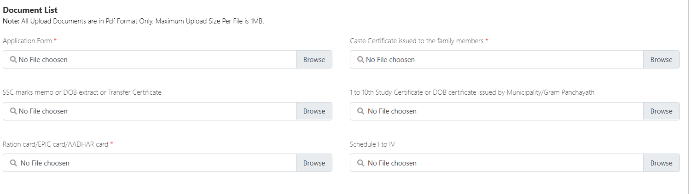
Provide AI Summary for each document covering the following points:
- Title of the document
- Key Details (if present in the document)
  - Name of the Applicant
  - Father’s Name
  - Address
  - Gender
  - Age/DOB
  - Phone Number
  - Ration Card Number
  - Community
  - Nativity
  - Family Income
  - Issuer of the Document/Authority Signed
  - Date of Issue

2. Income Certificate
This certificate is issued to ascertain the income sources and total income of an individual. This certificate is used for education & employment purposes, availing loans, etc.
List of Documents to be uploaded in the application form of Income Certificate:
- Application Form (mandatory)
- Ration card/EPIC card/Aadhaar Card (optional)
- Copy of IT Returns/Pay Slips (Any other documents) (optional)
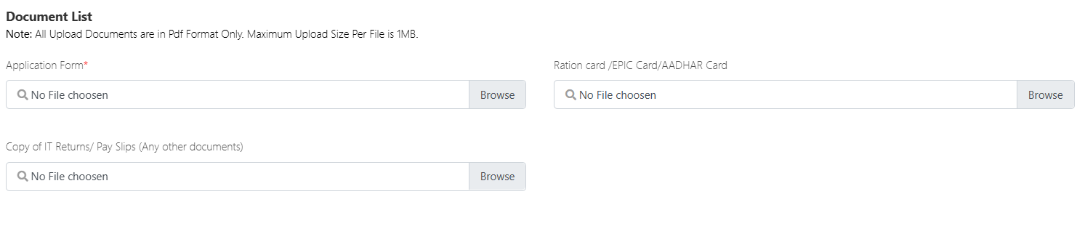
Provide AI Summary for each document covering the following points:
- Title of the document
- Key Details (if present in the document)
  - Name of the Applicant
  - Father’s Name
  - Address
  - Gender
  - Age/DOB
  - Phone Number
  - Ration Card Number
  - Income Details
    - Income on Lands
    - Income on Business
    - Income on Buildings
    - Income on Labour
    - Salary of both Wife & Husband
    - Income on Other Sources
    - Total Income
  - Issuer of the Document/Authority Signed
  - Date of Issue
3. OBC Certificate
This certificate is issued to citizens belonging to Other Backward Classes (OBC) castes and it is used for education and employment purposes.
List of Documents to be uploaded in the application form of OBC Certificate:
- Application Form (mandatory)
- Ration card/EPIC card/Aadhaar Card (optional)
- Applicant Father/Mother property particulars (mandatory)
- Applicant Father/Mother Employment particulars/Income Tax returns (for professionals) (mandatory)
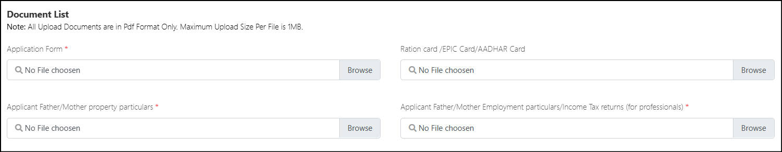
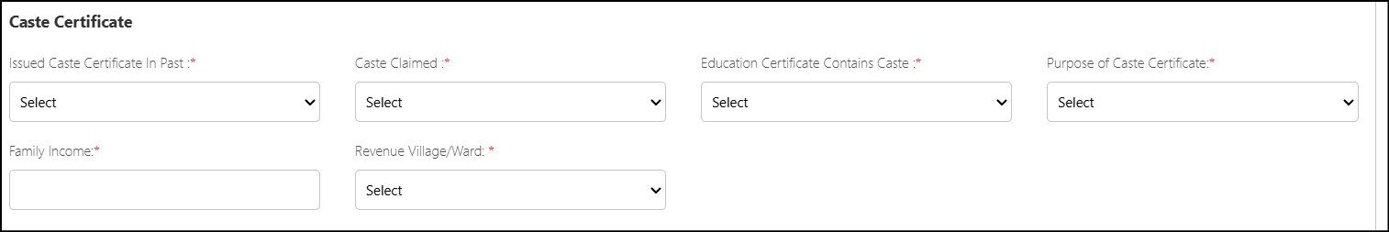
Provide AI Summary for each document covering the following points:
- Title of the document
- Key Details (if present in the document)
  - Name of the Applicant
  - Father’s Name
  - Address
  - Gender
  - Age/DOB
  - Phone Number
  - Caste
  - Sub-Caste
  - Family Income
  - Issuer of the Document/Authority Signed
  - Date of Issue

4. Issuance of Income & Asset Certificate for Economically Weaker Sections (EWS)
This certificate is issued to Economically Weaker Sections (EWS) of OCs for availing reservation at Central level. This certificate is valid up to one financial year.
List of Documents to be uploaded in the application form of EWS Certificate:
- Application Form (mandatory)
- Ration card/EPIC card/Aadhaar Card (mandatory)
- Copy of IT Returns/Pay slips (Any other documents) (optional)
- Affidavit (optional)
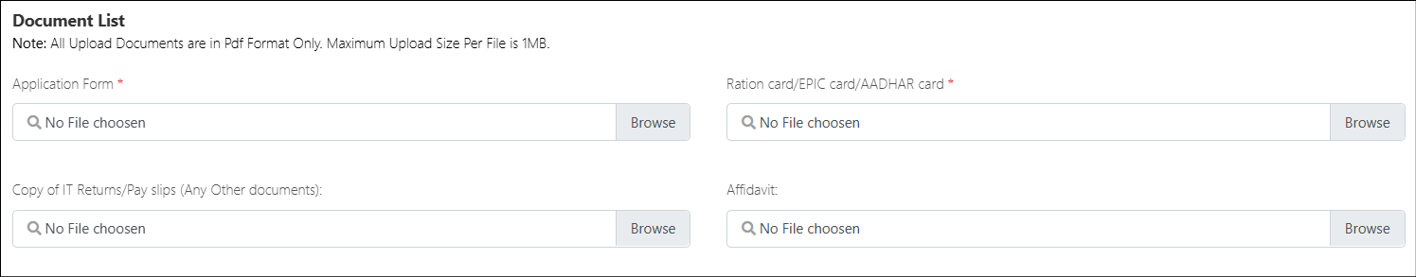
Provide AI Summary for each document covering the following points:
- Title of the document
- Key Details (if present in the document)
  - Name of the Applicant
  - Father’s Name
  - Address
  - Gender
  - Age/DOB
  - Phone Number
  - Ration Card Number
  - Community
  - Assets Details
    - Agriculture Land
    - Residential Flat
    - Residential Plot & Municipality
  - Gross Annual Income
  - Issuer of the Document/Authority Signed
  - Date of Issue

5. Family Member Certificate
This certificate is issued to the family members of the deceased Head of the Family (HOF). This is used for availing the benefits and updating the documents of properties and other details.
List of Documents to be uploaded in the application form of Family Member Certificate:
- Application Form (mandatory)
- A notarized affidavit containing Name, Age and Relationship with deceased (mandatory)
- Document (Ration Card/Voter Id/Passport/Passbook, Aadhaar etc.) indicating the relationship of the applicant with the deceased (mandatory)
- Death Certificate/FIR (mandatory)
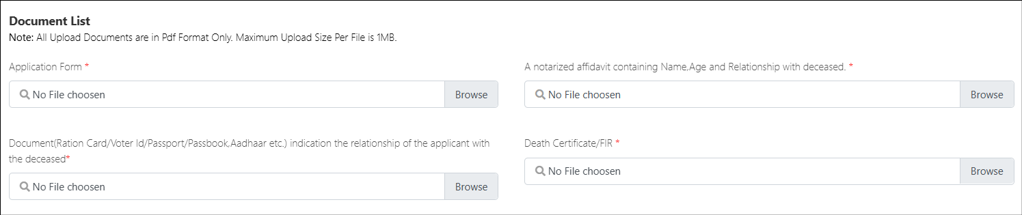
Provide AI Summary for each document covering the following points:
- Title of the document
- Key Details (if present in the document)
  - Name of the Applicant
  - Father’s Name
  - Address
  - Gender
  - Age/DOB
  - Phone Number
  - Deceased Details
    - Deceased HOF’s Name
    - Father/Husband Name
    - Date of Death
    - Reason for Death
    - Occupation
    - Aadhaar Number
    - Place of Death
  - Details of Family Members of the Deceased HOF
    - Name
    - Gender
    - Age
    - Relationship with HOF
  - Issuer of the Document/Authority Signed
  - Date of Issue

